REST Countries API

🌍 What Is REST Countries API?
# Source: AI Source: Provided by: [Data Path: Persons Table -> ID Column: 1, Name_En Column: Motasem Essam] -> From: [ChatGPT] on [1/19/2026]
The REST Countries API is a free and easy-to-use web service that provides detailed data about countries around the world. It’s commonly used in apps, websites, and projects to retrieve country information, such as:
- Name, flag, capital, population
- Languages, currencies, and regions
- Country codes, timezones, borders
- Maps, demonyms, and more

✅ What You Can Do with REST Countries API
# Source: AI Source: Provided by: [Data Path: Persons Table -> ID Column: 1, Name_En Column: Motasem Essam] -> From: [ChatGPT] on [1/19/2026]
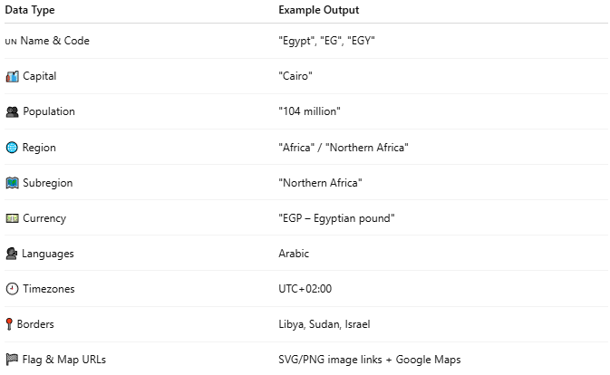

Data Type | Example Output
🇺🇳 Name & Code | "Egypt", "EG", "EGY"
🏙️ Capital | "Cairo"
👥 Population | "104 million"
🌐 Region | "Africa" / "Northern Africa"
🗺️ Subregion | "Northern Africa"
💵 Currency | "EGP – Egyptian pound"
🗣️ Languages | Arabic
🕘 Timezones | UTC+02:00
📍 Borders | Libya, Sudan, Israel
🏁 Flag & Map URLs | SVG/PNG image links + Google Maps

🔗 API Endpoint Examples (No API Key Required)
# Source: AI Source: Provided by: [Data Path: Persons Table -> ID Column: 1, Name_En Column: Motasem Essam] -> From: [ChatGPT] on [1/19/2026]
- Get all countries:
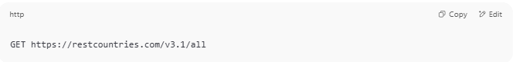
GET https://restcountries.com/v3.1/all

- Search by country name:
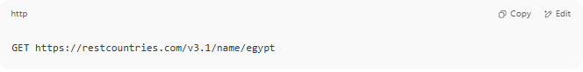
GET https://restcountries.com/v3.1/name/egypt

- Search by country code (ISO):
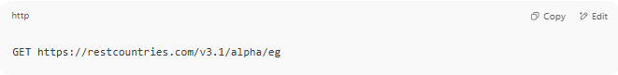
GET https://restcountries.com/v3.1/alpha/eg

- Search multiple country codes:
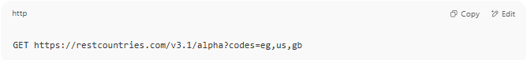
GET https://restcountries.com/v3.1/alpha?codes=eg,us,gb

📤 Example Response (Search for "Egypt")
# Source: AI Source: Provided by: [Data Path: Persons Table -> ID Column: 1, Name_En Column: Motasem Essam] -> From: [ChatGPT] on [1/19/2026]
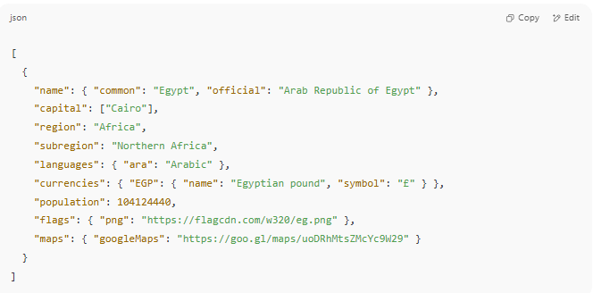
[
{
"name": { "common": "Egypt", "official": "Arab Republic of Egypt" },
"capital": ["Cairo"],
"region": "Africa",
"subregion": "Northern Africa",
"languages": { "ara": "Arabic" },
"currencies": { "EGP": { "name": "Egyptian pound", "symbol": "£" } },
"population": 104124440,
"flags": { "png": "https://flagcdn.com/w320/eg.png" },
"maps": { "googleMaps": "https://goo.gl/maps/uoDRhMtsZMcYc9W29" }
}
]

🛠️ Example Use Case
# Source: AI Source: Provided by: [Data Path: Persons Table -> ID Column: 1, Name_En Column: Motasem Essam] -> From: [ChatGPT] on [1/19/2026]
Create a country selector dropdown with:
- Flag image
- Country name
- Capital and currency
- Link to Google Maps

🧪 Test It Now
# Source: AI Source: Provided by: [Data Path: Persons Table -> ID Column: 1, Name_En Column: Motasem Essam] -> From: [ChatGPT] on [1/19/2026]
Try it in your browser:
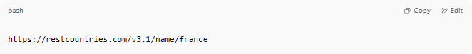
https://restcountries.com/v3.1/name/france

Or test all countries:
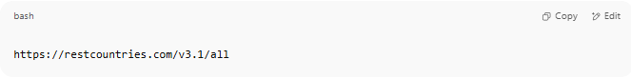
https://restcountries.com/v3.1/all

Example
# Source: ScreenShot Source: Provided by: [Persons Table -> ID Column: 1, Name_En Column: Motasem Essam] -> Tool: [Lightshot Program] -> From [Program: Postman] on [1/19/2026]
https://restcountries.com/v3.1/all?fields=name,capital,flags
https://restcountries.com/v3.1/all?fields=name,capital,flags
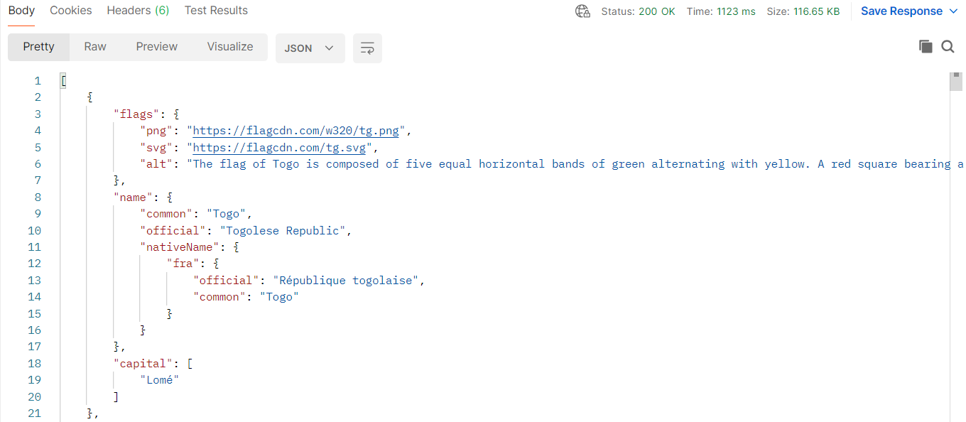
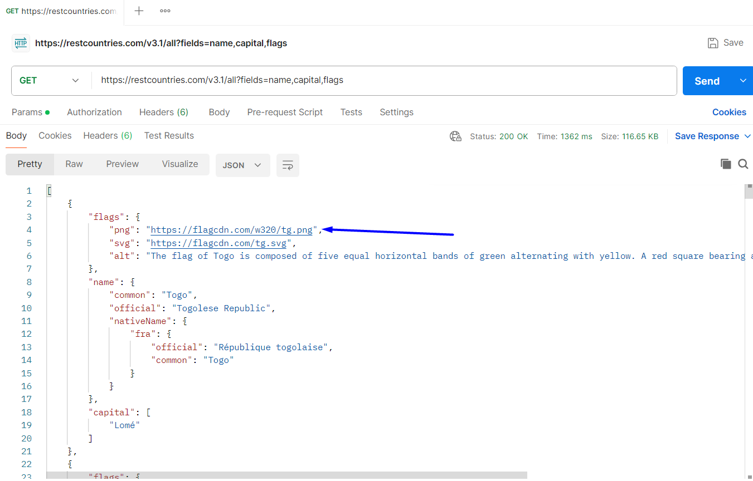
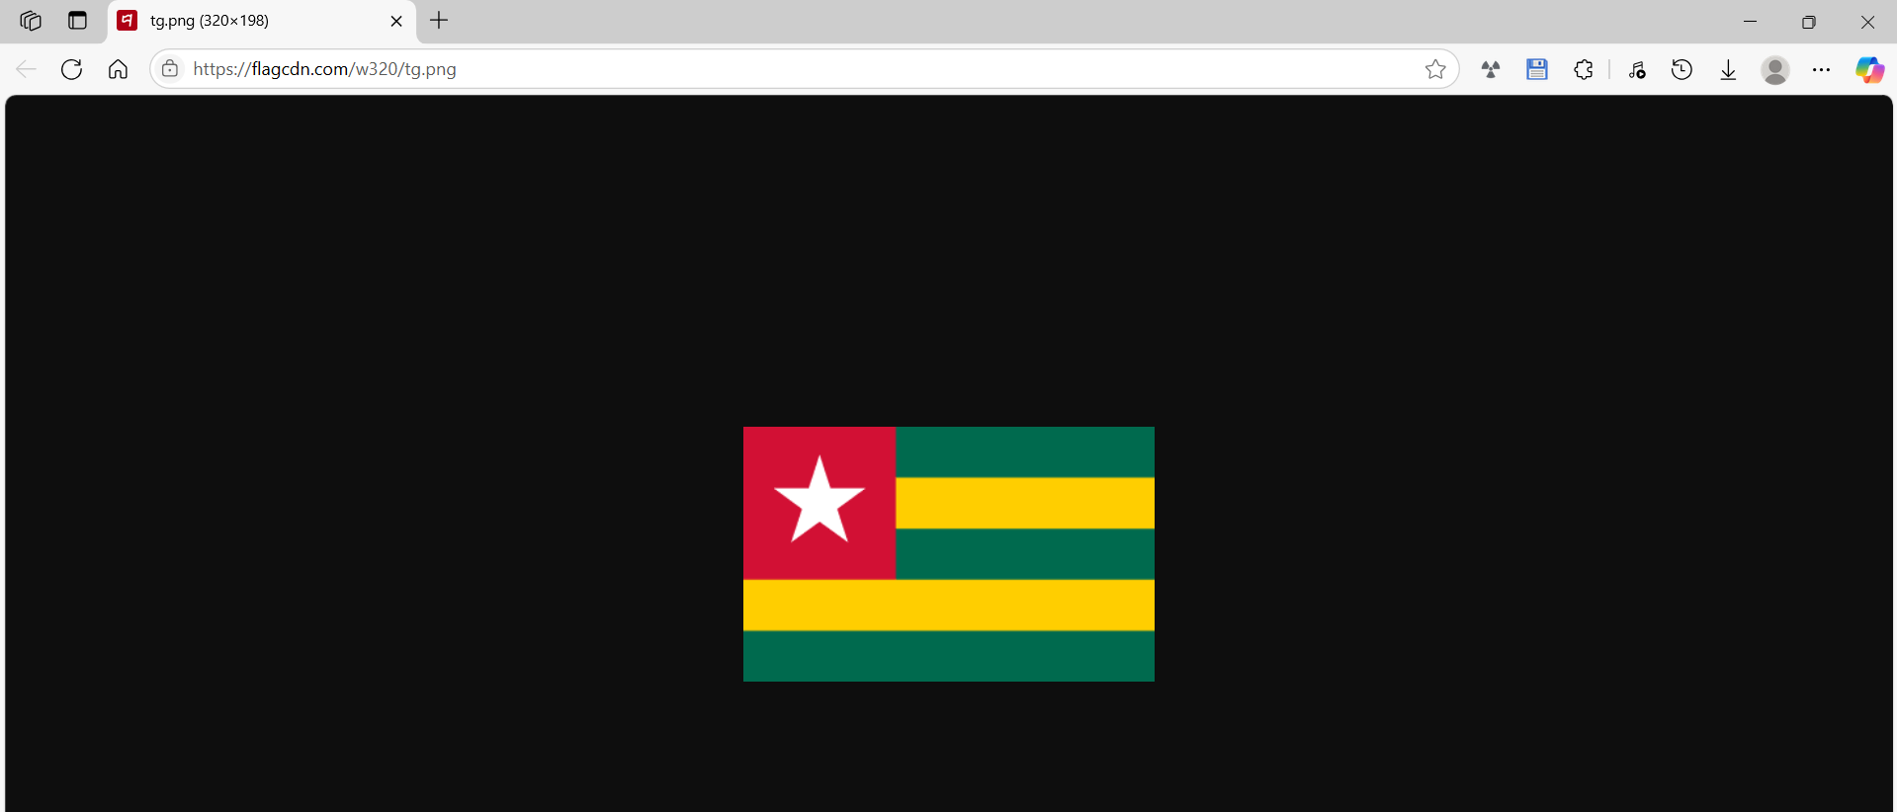
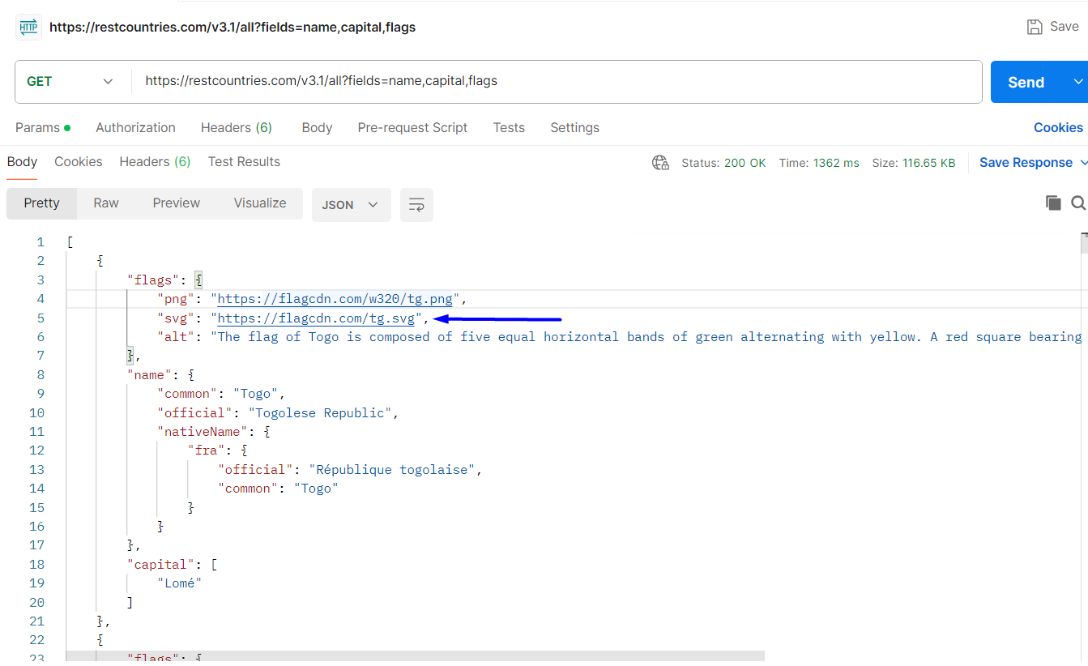
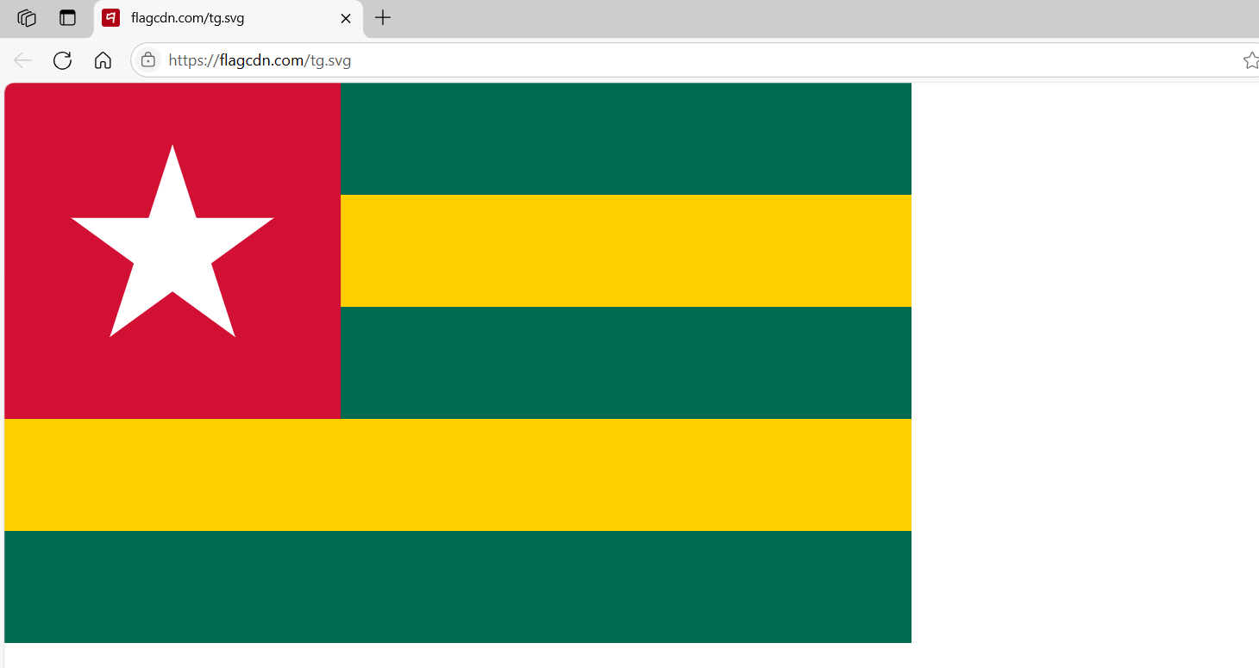

https://restcountries.com/v3.1/name/france
